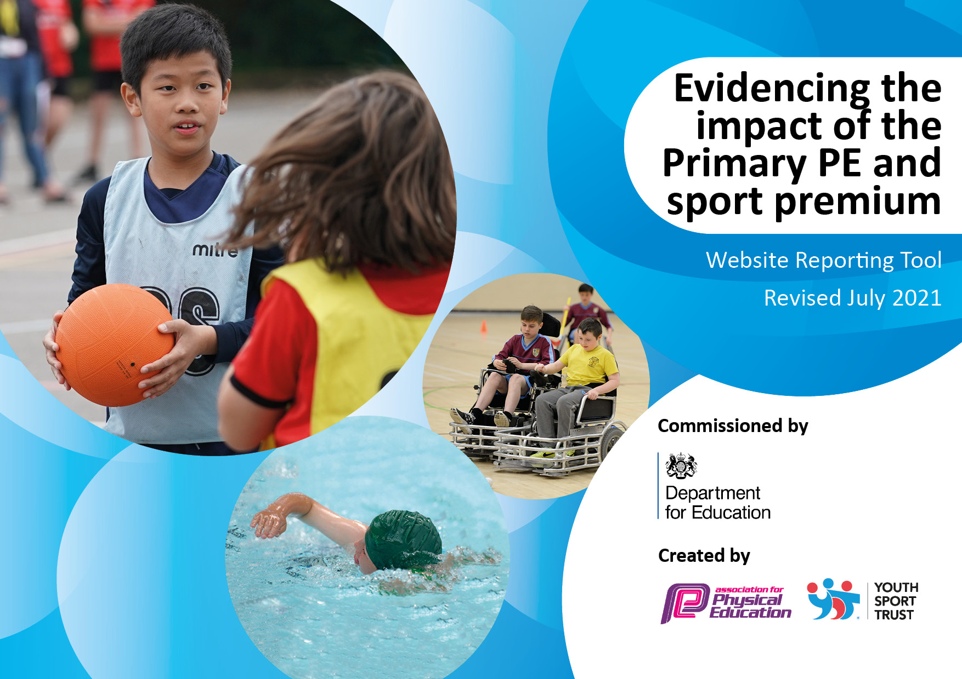
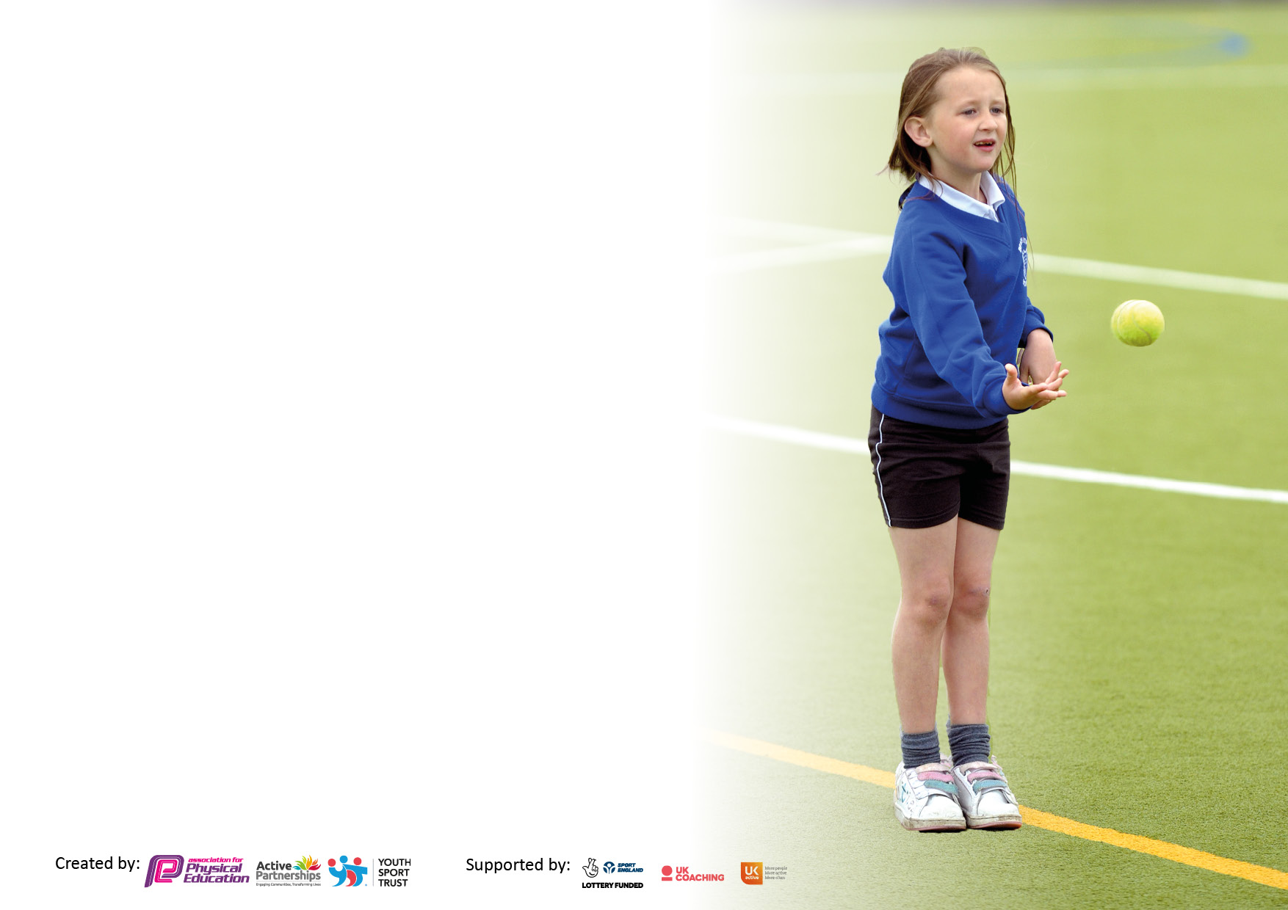

It is important that your grant is used effectively and based on school need. The Education Inspection Framework makes clear there will be a focus on ‘whether leaders and those responsible for governors all understand their respective roles and perform these in a way that enhances the effectiveness of the school’.

Under the Quality of Education Ofsted inspectors consider:
Intent - Curriculum design, coverage and appropriateness
Implementation - Curriculum delivery, Teaching (pedagogy) and Assessment
Impact - Attainment and progress

To assist schools with common transferable language this template has been developed to utilise the same three headings which should make your plans easily transferable between working documents.

Schools must use the funding to make additional and sustainable improvements to the quality of Physical Education, School Sport and Physical Activity (PESSPA) they offer. This means that you should use the Primary PE and sport premium to:

- Develop or add to the PESSPA activities that your school already offer
- Build capacity and capability within the school to ensure that improvements made now will benefit pupils joining the school in future years
- The Primary PE and sport premium should not be used to fund capital spend projects; the school’s budget should fund these.

Pleasevisitgov.ukfortherevisedDfEguidanceincludingthe5keyindicatorsacrosswhichschoolsshoulddemonstrate animprovement.Thisdocumentwillhelpyoutoreviewyourprovisionandtoreportyourspend.DfEencouragesschools to use this template as an effective way of meeting the reporting requirements of the Primary PE and sport premium.

We recommend you start by reflecting on the impact of current provision and reviewing the previous spend.

Schools are required to publish details of how they spend this funding, including any under-spend from 2019/2020, as well as on the impact it has on pupils’ PE and sport participation and attainment. All funding must be spent by 31st July 2022.

We recommend regularly updating the table and publishing it on your website throughout the year. This evidences your ongoing self-evaluation of how you are using the funding to secure maximum, sustainable impact. Final copy must be posted on your website by the end of the academic year and no later than the 31st July 2021. To see an example of how to complete the table please click HERE.

Details with regard to funding
Please complete the table below.

Total amount carried over from 2019/20 | £4,306
Total amount allocated for 2020/21 | £17,556
How much (if any) do you intend to carry over from this total fund into 2021/22? | £N/A
Total amount allocated for 2021/22 | £17,470
Total amount of funding for 2021/22. To be spent and reported on by 31st July 2022. | £17,470
Swimming Data
Please report on your Swimming Data below.

Meeting national curriculum requirements for swimming and water safety.  N.B. Complete this section to your best ability. For example you might have practised safe self-rescue techniques on dry land which you can then transfer to the pool when school swimming restarts.  Due to exceptional circumstances priority should be given to ensuring that pupils can perform safe self rescue even if they do not fully meet the first two requirements of the NC programme of study | N/A
What percentage of your current Year 6 cohort swim competently, confidently and proficiently over a distance of at least 25 metres?  N.B. Even though your pupils may swim in another year please report on their attainment on leaving primary school at the end of the summer term 2020.  Please see note above | N/A
What percentage of your current Year 6 cohort use a range of strokes effectively [for example, front crawl, backstroke and breaststroke]?  Please see note above | N/A
What percentage of your current Year 6 cohort perform safe self-rescue in different water-based situations? | N/A
Schools can choose to use the Primary PE and sport premium to provide additional provision for swimming but this must be for activity over and above the national curriculum requirements. Have you used it in this way? | No

Action Plan and Budget Tracking
Capture your intended annual spend against the 5 key indicators. Clarify the success criteria and evidence of impact that you intend to measure to evaluate for pupils today and for the future.

Academic Year: 2020/21 | Total fund allocated: | Date Updated: June 2022
Key indicator 1: The engagement of all pupils in regular physical activity – Chief Medical Officers guidelines recommend that primary school pupils undertake at least 30 minutes of physical activity a day in school |  |  |  | Percentage of total allocation:
 |  |  |  | 60%
Intent | Implementation |  | Impact
Your school focus should be clear what you want the pupils to know and be able to do and about  what they need to learn and to  consolidate through practice: | Make sure your actions to achieve are linked to your intentions: | Funding allocated: | Evidence of impact: what do pupils now know and what can they now do? What has changed?: | Sustainability and suggested next steps:
- All pupils to be engaged in regular, high quality PE at school.  - Children will be offered a broad range of sports and activity.  - Children at Laceyfield will enjoy an active, healthy lifestyle.  - Introduce children to new sports through after school clubs and school visitors.  - Take part in walk to school week (whole school) (£125) | - To increase physical activity and structured play opportunities at break times  - To provide a range of active after school clubs in school.  - To continue to provide sports clubs at lunch times  - To target inactive / less confident children for lunch clubs using an ‘invite-only’ approach.  - All classes took part in ‘Walk to school week’ | £10,500 | - An increase in numbers of pupils engaging in lunch and after school clubs.  - An increase in physical play at lunch and break times due to new play equipment.  - Permanent, year round play equipment to be installed.  - Discussions around active travel and intra class competition. | - Rotation of after school club participants to increase engagement of the least active children  - Review long term plan to ensure provision is varied and progressive.  - Further opportunities throughout the day to reach the government target of 30 minutes of physical activity per day.  - Continue to take part in walk to school week in 2022/23.
Key indicator 2: The profile of PESSPA being raised across the school as a tool for whole school improvement |  |  |  | Percentage of total allocation:
 |  |  |  | 5%
Intent | Implementation |  | Impact
Your school focus should be clear what you want the pupils to know and be able to do and about  what they need to learn and to  consolidate through practice: | Make sure your actions to achieve are linked to your intentions: | Funding allocated: | Evidence of impact: what do pupils now know and what can they now do? What has changed?: | Sustainability and suggested next steps:
- To provide the necessary equipment to allow for quality first teaching.  - Use of the website, media and social media to promote school sport.  - In school displays to promote sporting achievements and participation in sport outside of school. | - Continued staff CPD alongside JB Sports coaches.  - Involvement with community events such as Louth Race for Life.  - Restocking of PE cupboard where necessary (£105).  - Promote school sport via the website and Twitter accounts.  - Displays in central areas to promote sport and intra-school competition. | £900 | - Involvement with the local community eg Run for life and Magna Vitae.  - Confidence and increased knowledge among teaching staff.  - Adequate equipment available to provide a broad and varied PE curriculum. | - Raise the profile of Laceyfield PE via social media channels.  - Pupil voice and staff questionnaires to review the impact of school sport.  - Whole school focus on significant events such as the World cup, Wimbledon.  - SportsBee of the term to be celebrated in the final assembly of term.

Key indicator 3: Increased confidence, knowledge and skills of all staff in teaching PE and sport |  |  |  | Percentage of total allocation:
 |  |  |  | 10%
Intent | Implementation |  | Impact
Your school focus should be clear | Make sure your actions to | Funding | Evidence of impact: what do | Sustainability and suggested
what you want the pupils to know | achieve are linked to your | allocated: | pupils now know and what | next steps:
and be able to do and about | intentions: |  | can they now do? What has
what they need to learn and to |  |  | changed?:
consolidate through practice:
- Staff will develop their knowledge of PE skills and develop a range of quality teaching approaches.  - Teachers will feel confident delivering PE lessons that cater for all. | - Continued CPD alongside professional Sports coaches  - Lifewise subscription (£426). | £1750 | - Increased competency and confidence of all staff when delivering PE lessons.  - Quality teaching and learning. | - Staff will teach PE with confidence.  - Continued sports coaching and clubs.
Key indicator 4: Broader experience of a range of sports and activities offered to all pupils |  |  |  | Percentage of total allocation:
 |  |  |  | 20%
Intent | Implementation |  | Impact
Your school focus should be clear | Make sure your actions to | Funding | Evidence of impact: what do | Sustainability and suggested
what you want the pupils to know | achieve are linked to your | allocated: | pupils now know and what | next steps:
and be able to do and about | intentions: |  | can they now do? What has
what they need to learn and to |  |  | changed?:
consolidate through practice:
- To use visitors from local clubs to promote new sports to our children.  - To engage in a variety of different activities across the year.  - To provide opportunities for all children to enjoy physical activity.  - Dan the skipping man for all children EYFS-Y6. (£600) | - Skipping workshops for all children (£600)  - Involvement with ‘Still me’ and Race for life community projects  - Be a part of the school sports partnership  - Enable all children to take part in school sports days.  - Be a part of inter school competition  - Raise the profile of girls participation in sports. | £3500 | - A range of sports and visitors offered, such as LCC cricket in the summer term, football clubs for after school and games during lunch clubs.  - Increased numbers taking part in sports through lunch clubs and after school clubs. | - Ensure PE continues to be exciting and interesting.  - Use of staff as role models.  - To continue cross curricular links through the ‘Be well’ approach.  - Continue links with local sports clubs.  - Ensure after school and lunch clubs provide a range of engaging sports.  - Continue to use pupil voice to inform after school club provision.  - Explore the possibility of having a visit for each year group (swimming, back to bear, climbing, tennis etc)

Key indicator 5: Increased participation in competitive sport |  |  |  | Percentage of total allocation:
 |  |  |  | 5%
Intent | Implementation |  | Impact
Your school focus should be clear | Make sure your actions to | Funding | Evidence of impact: what do | Sustainability and suggested
what you want the pupils to know | achieve are linked to your | allocated: | pupils now know and what | next steps:
and be able to do and about | intentions: |  | can they now do? What has
what they need to learn and to |  |  | changed?:
consolidate through practice:
- Sports days with parental involvement  - Skipping challenges with the Wolds School Sports Partnership  - An introduction to competitive sport and team games during PE lessons  - Signed up for inter-school KS1 competition at Lacey Gardens. | - Introduce KS1 intra-school opportunities.  - Sports challenges during National School Sports week  - Sports days for all year groups attended by parents and carers.  - Be a part of the Wolds School Sports Partnership. | £900 | - Children took part in year group sports days attended by parents.  - Signed up for the KS1 inter school cricket competition hosted by Lacey Gardens.  - ‘Scores on the doors’ used to record scores for spring term sports. | - Class competitions, intra-class competitions.  - Continue to involve teams of children for inter school competition days.

Signed off by
Head Teacher: | Emma Beveridge
Date: | 20.6.22
Subject Leader: | Abi Tinker
Date: | 20.6.22
Governor: | Karl Gabbitas
Date: | 20.6.22

