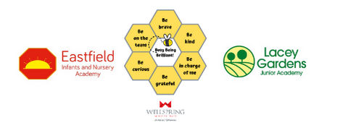

LACEYFIELD
GOVERNOR DECLARATIONS OF INTEREST 2021-22
REGIONAL GOVERNANCE OFFICER : KATE STORR

NAME | DATE APPOINTED | ROLE | DECLARATIONS OF INTEREST
Farhan Ahmed | July 2021 | Trust Appointed | none
Emma Beveridge | n/a | Executive Principal (Ex Officio) | none
Gareth Cookson | March 2022 | Trust Appointed | Assistant Principal Toll Bar Academy
Natasha Corcoran | November 2020 | Parent Governor | none
Karl Gabbitas | June 2019 | Trust Appointed (Chair) | Chair of Governors at Littlecoates Primary Academy
Natalie Hardman | September 2021 | CEO Representative (Ex Officio) | none
Krissy Hipgrave | November 2018 | Staff | none
Daniel Reynolds | May 2019 | Staff | none
Ann Thomas | January 2020 | Parent | None

