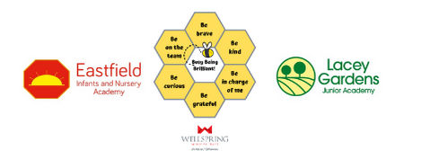

LACEYFIELD
LGB MEETING DATES SEPTEMBER 2021 – JULY 2022

Monday 20th September 2021

Monday 8th November 2021

Monday 7th March 2022

Monday 9th May 2022

Monday 27th June 2022

Monday 18th July 2022

All meetings start at 4.30pm unless otherwise indicated

Regional Governance Officer:
Kate Storr
Telephone 07375 391840
E-mail k.storr@wellspringacademies.org.uk

