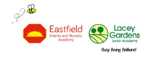
EYFS on a page

The EYFS long term plan is first and foremost the EYFS Statutory framework. The Framework is divided into 3 sections:

1.Characteristics of Effective Learning.
2. 3 prime areas of learning
3. 4 specific areas of learning

Characteristics of Effective learning
The characteristics of effective learning look at ways in which the child engages with other people and their environment. They also underpin learning and development across all areas and support the child to remain an effective and motivated learner.
These are:
- Playing and Exploring
- Active Learning
- Creating and thinking critically

At LaceyField our mission is ‘Busy Being Brilliant’. To help children understand about how they can develop effective learning behaviours we encourage children to use our ‘BEEhaviours for Learning’ as they play and learn. These link closely to the EYFS Characteristics of Effective Learning.

Areas of Learning in the EYFS
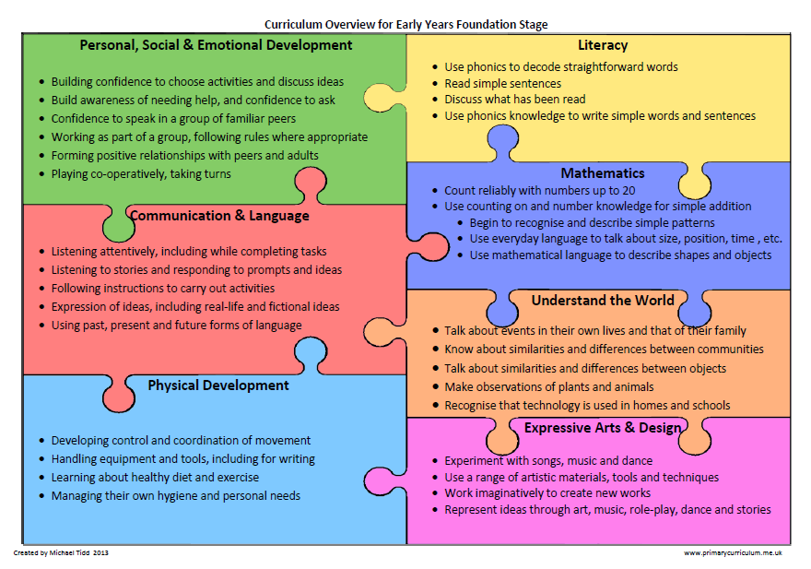
The EYFS framework also describes the seven areas of learning that are divided into Prime and Specific areas. These are implemented through planned purposeful play.
Prime Areas
Personal, Social and Emotional Development
Communication and Language
Physical Development
Specific Areas
Literacy
Mathematics
Understanding the World
Expressive Arts and Design

Learning and Development in the EYFS
Early Years and its practice is the most important time of a child’s school life and one in which they will do their crucial learning. At LaceyField we know play underpins this. It also underpins learning and all aspects of children’s development. It is through play, our children develop language skills, their emotions and creativity, social and intellectual skills. For most children their play is natural and spontaneous although some children may need extra help from adults.
At LaceyField, Play takes place indoors and outdoors and it is in these different environments that children explore and discover their immediate world. It is here they practise new ideas and skills, they take risks, show imagination and solve problems on their own or with others.

At LaceyField we ensure that there is a balance between adult led and child initiated activities across the day. We believe that skilful interactions with adults supports learning and embeds skills and knowledge. The role of the adult is to continually model, demonstrate and question. It is also to observe the children in their play, establish where they are in their own development pathway and then identify next steps.

When the children are in continuous provision, our practitioners go into their play and we look for opportunities to deliver next steps objectives through the resources and ideas that are engaging the children most at the moment.

We have found this to be a method of teaching that enhances and supports children’s play. As we are co-adventuring with the children we get much higher levels of engagement.
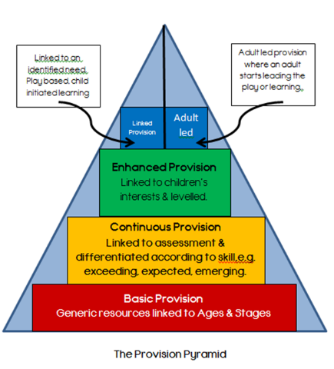
Effective Environments
At LaceyField, our environments have been created to allow children to have lots of opportunities to play freely, but also support their learning through implicit and explicit challenge.
- They contain resources that are open to interpretation and exploration. (Playing and Exploring)
- They are led by children’s interests and give children lots of opportunities for learning on their own. (Active Learning)
- They provide lots of opportunities to think, puzzle and work things out on their own and with others. (Creating and thinking critically)
In our EYFS classrooms 3 different types of provision can be seen.

EYFS curriculum
At LaceyField, Reading and developing an appreciation for books is a foundation for all other learning and we consider it to be of the utmost importance. This is therefore used for the basis of our curriculum. Texts are selected to match the personal interests of the children as these are the driving force for building knowledge, skills and understanding. This has helped to promote a love of reading and has developed rich and varied language which is being transferred into the children’s own child initiated learning experiences.

