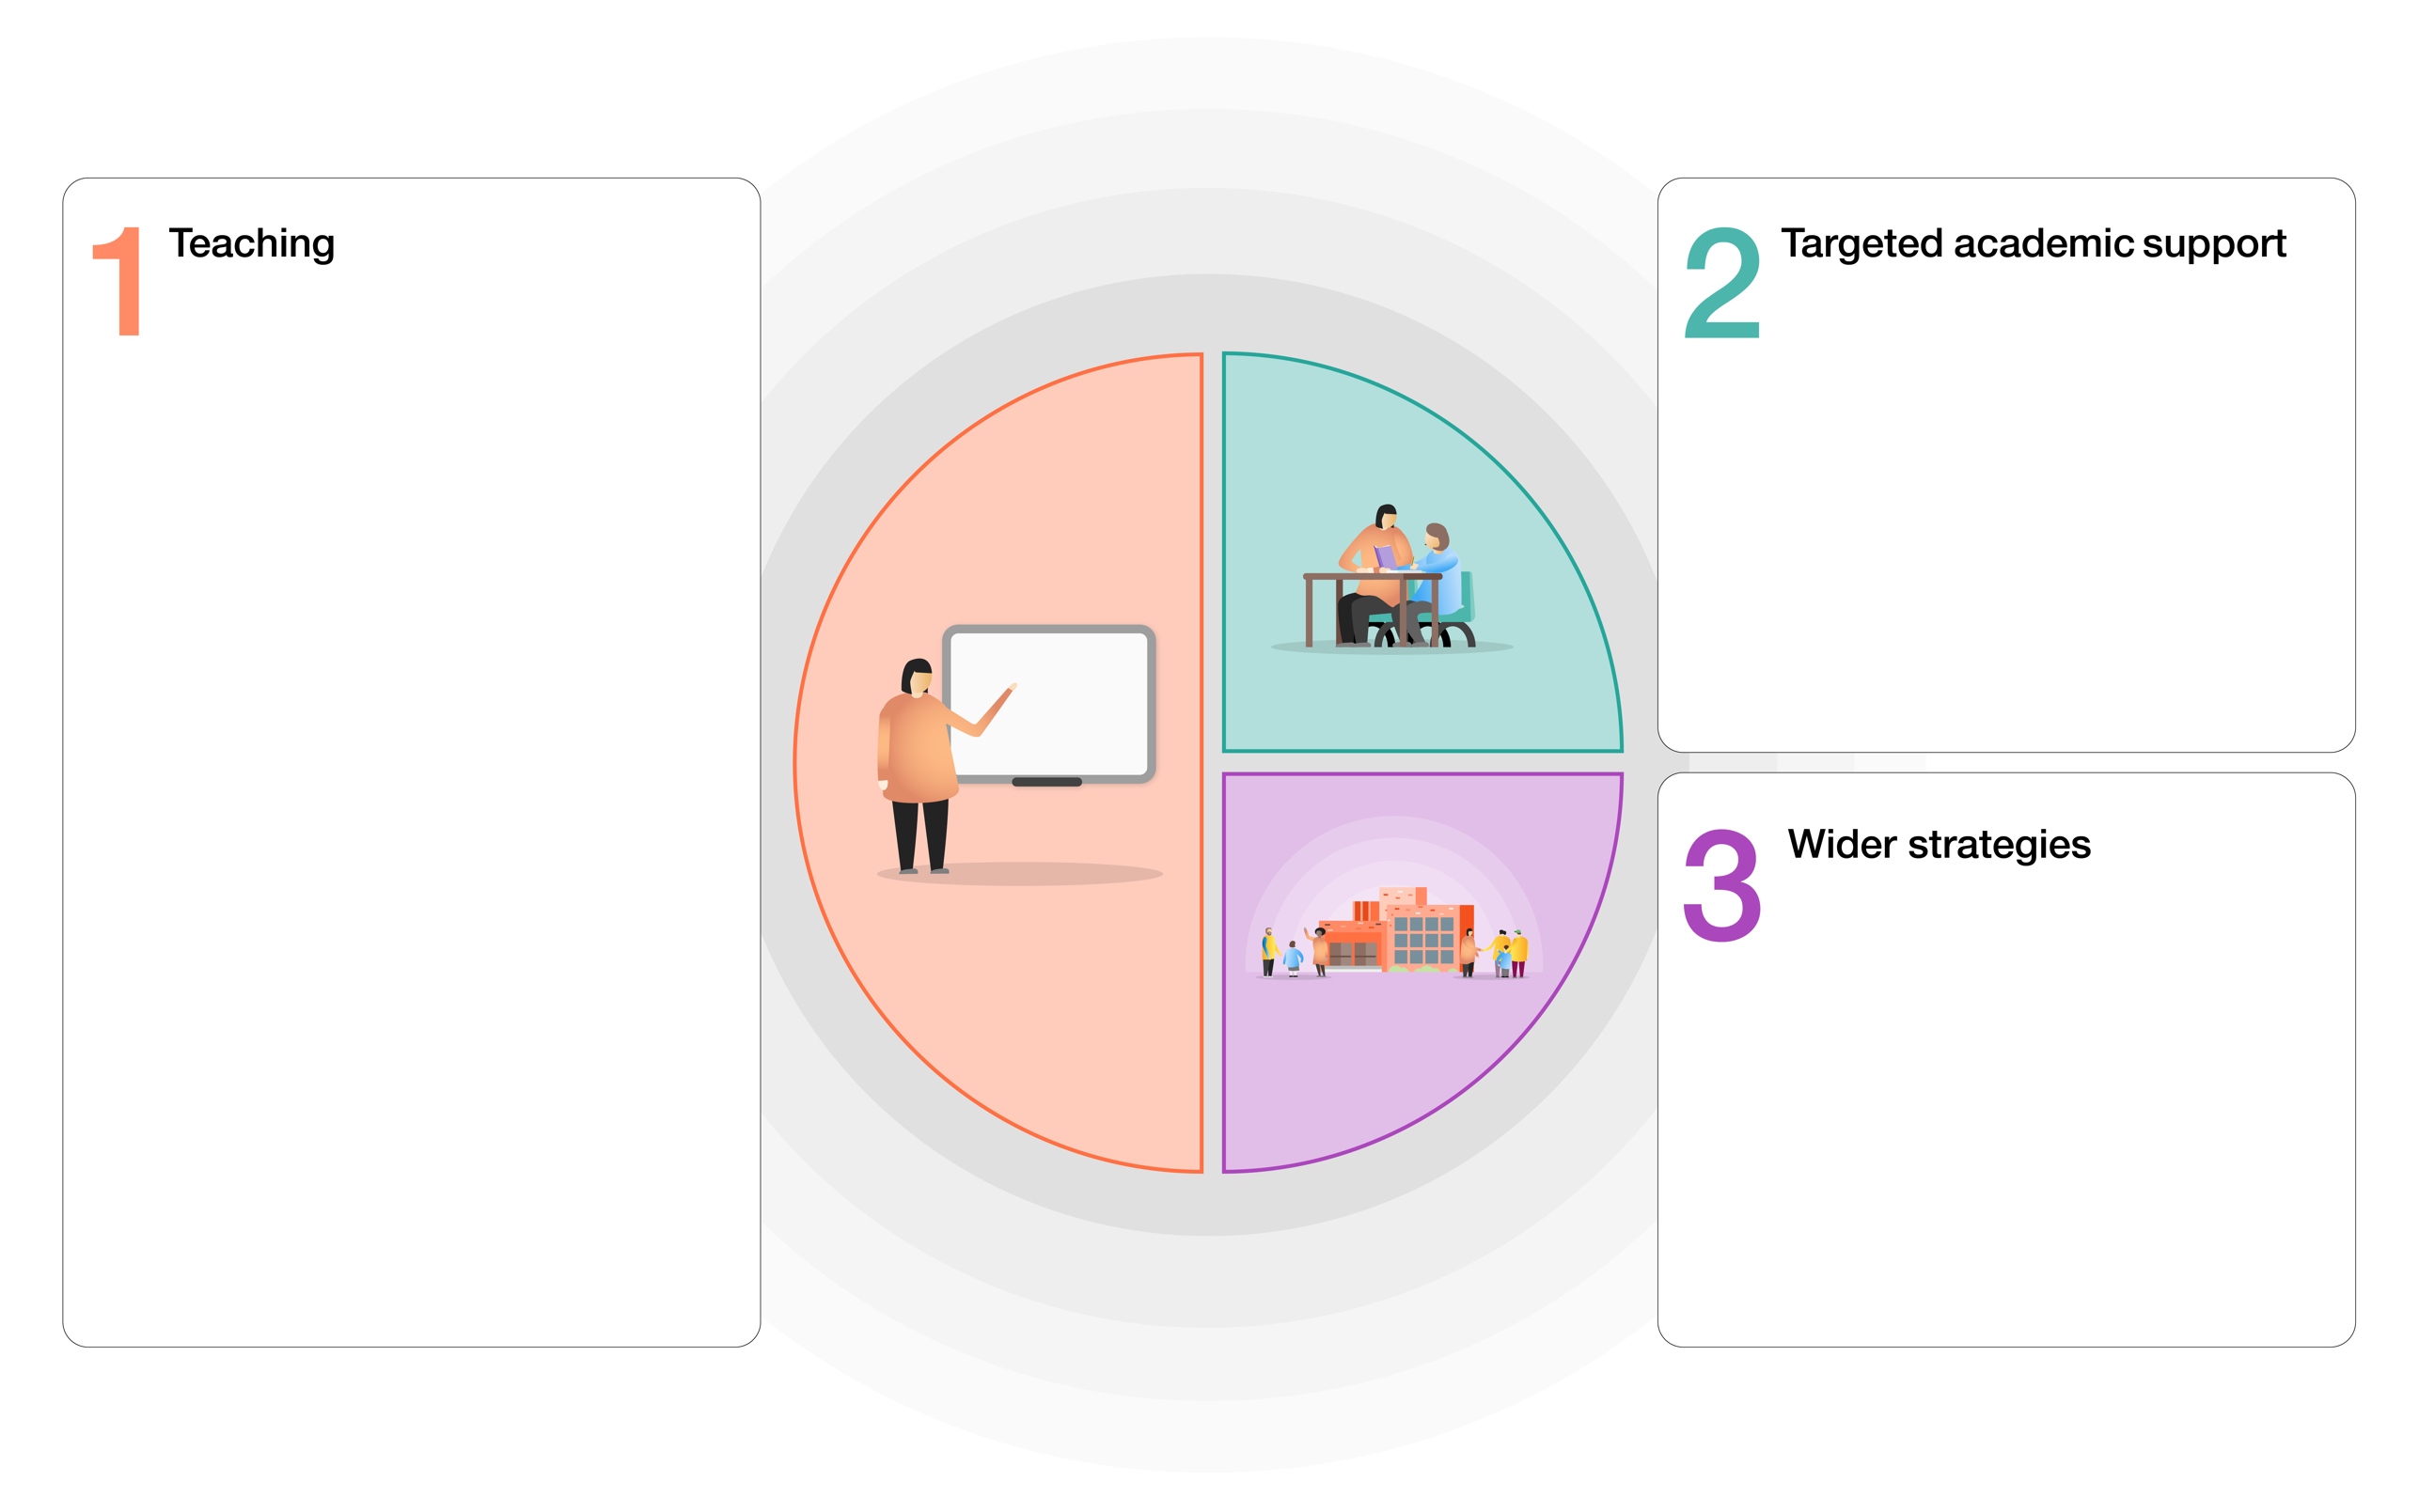

~ Nurture breakfast for all

~ Whole school physical environment planned with safe spaces.

~ Development of ‘Bee Well’ identifying emotions and self- regulation strategies.

~ Vulnerable learners receive additional support for home learning through accessibility to electronic devices, phone calls to support learning and feedback.

~ A full program, for all year groups, of specific interventions that will incorporate additional support hours from Jan 2021.

~ Pre-teach and same-day interventions

~ Raise Year 6 standards through PiXL assessment and intervention

~ Continue to collaborate with RWI TT phonics project.

~ Quality First Teaching supported by evidence informed CPD for teachers and support staff.

~ A broad and engaging curriculum that focuses on vocabulary acquisition.

~ Curriculum ‘essentials’ for Reading, Writing and Maths are identified and taught / revisited across wider curriculum subjects.

~ Careful planning and differentiation to meet the individual needs of ALL SEND pupils.

~ Whole – school writing approach underpinned by The Power of Reading.

~ Further development of Maths Mastery approach – with additional focus on feedback.

~ Google classroom/Tapestry to be further developed for home and in school learning.

**Laceyfield COVID 19 Catch Up Premium Plan (2020-21) – TIERED MODEL**