LaceyField Speech, Language and Communication.

At Eastfield Infants and Lacey Gardens Junior Academy, our aspiration for each of our children is based upon the need for them to enter the world of work as articulate, confident individuals who have a vast wealth of words. We recognise the vital importance of speech and language development and how it is a crucial factor for success at school and beyond. We strive to give pupils a stimulating environment, where meaningful speech, language and communication opportunities are valued and fostered as a central part of all our practice.

Words make us who we are, and they help us to become who we can be.

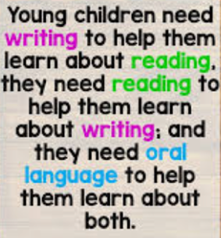
Our Aims and Purpose
- Confident speakers
- Thriving, empathetic communicators
- Word rich learners
- Evoke word consciousness
- Communicators who are readers and writers

How do we do it?
- Teachers will model good, authentic communication.
- Teachers will support and extend speech, language and communication through receptive interactions.
- Environments will provide spaces that stimulate and foster speech, language and communication. All conversations and ideas are accepted and valued.
- Early intervention is key; children with specific reading, speech and language or hearing difficulties will be identified and supported through intervention programmes in school.
The LaceyField Strategies
- Nurture breakfasts.
- Narrating children’s play in the Early Years.
- Scaffolding and extending responses.
- Asking of meaningful questions to challenge thinking.
- Shared Reading/story time (class text)
Whole Class Reading.
- Vocabulary valued and introduced across the curriculum.
- Word depth explored (etymology, morphology…)
- Time and space given to talk.
- Home languages celebrated and supported.

The fundamentals
- A belief that every child can and will become a successful communicator.
- All contributions are listened to and valued.
- Opportunities for speech, language and communication are seized throughout the daily routine.
- A focus on adapting questions and responses.
- Blue/Green partner work.
- An ‘I do, We do, You do’ approach.
- Pre-teaching of vocabulary.
- Exposure to a variety of high quality resources - fiction, non-fiction, pictures, poems and songs.
- Age appropriate vocabulary walls and vocabulary collecting.
- Interventions.
- Parental engagement.

Planning
Teachers skilfully weave Tier 1, Tier 2, and Tier 3 words into their lessons, year group specific words inform teacher’s planning and teachers follow a cyclical approach to teaching reading and vocabulary. We strongly believe children learn best when the teaching of language and vocabulary is used in everyday contexts, continuously revisited, built on and deepened.
‘Busy Being Brilliant!’

