Laceyfield Maths
At Lacey Gardens Junior Academy we recognise that mathematics is essential to everyday life, critical to science, technology and engineering, and necessary for financial literacy and most forms of employment. Therefore, we recognise the importance of a high quality mathematics curriculum. We follow a mastery approach in order to allow every child to succeed.
Our Aims and Purpose
- to promote enjoyment and enthusiasm for learning through practical activity, exploration and discussion
- for children to become fluent in the fundamentals of mathematics so that they are able to recall and apply their knowledge rapidly and accurately
- for children to be able to reason mathematically by following a line of enquiry, hypothesising about relationships and generalisations, and developing an argument, justification or proof using mathematical language
- for children to be able to solve problems by applying their mathematics to a variety of routine and non-routine problems with increasing sophistication
- for children to be able to demonstrate and develop effective learning behaviours such as: perseverance, collaboration, questioning and organisation
- to develop children’s understanding of the importance of Mathematics in everyday life

How do we do it?
Mathematics is taught as a discrete lesson, every day. In KS2, we follow the ‘same day intervention approach’, whereby teachers deliver the input, children answer 6/7 diagnostic questions and the questions are then marked whilst the children are in assembly. After assembly, the intervention or deeper thinking tasks will take place. Where possible, the intervention will take place with the teacher, whilst the teaching assistant supports the rest of the class. In all lessons, we use a CPA approach to develop a deep and sustainable understanding of maths. The CPA approach builds on children’s existing knowledge by introducing abstract concepts in a concrete and tangible way. Where appropriate, all children engage in the objectives specified in the National Curriculum for their year group. Where this is not possible, teachers are expected to differentiate appropriately.

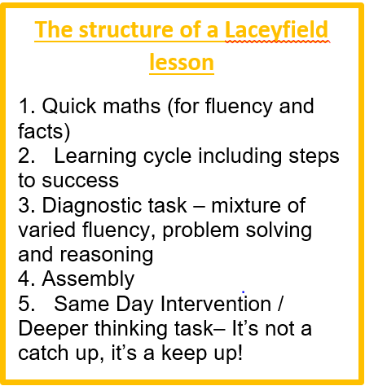
The fundamentals
- A belief that every child can and will achieve mastery
- Bespoke Laceyfield medium term plan
- A focus on task design – everything is done on purpose
- Blue partner/ Green Partner
- Quick maths for fluency
- Knowledge organisers for each unit
- Same Day Intervention
- All children will reason and problem solve
- Whole Class Choral Response
- Learning question and steps to success (created with the class)
- S planning
- Conceptual and procedural variation
- Up-to-date working walls
- Concrete – Pictorial – Abstract
- Use of resources including pictorial in all year groups
- A focus on ‘grown up mathematical’ vocabulary
- Pace, productivity, progress
- Bar modelling
- Children use Times Tables Rockstars
- Deeper/ sustainable learning

Planning
Teachers use the Laceyfield Bespoke medium term plans. This highlights when each strand should be taught throughout the year. This plan provides adequate time to be spent on each unit in order for children to achieve depth. We also believe in a cyclical approach to teaching maths, as we strongly believe children learn best when small steps are continuously revisited, built on and deepened. Therefore, where possible, some units are revisited in the summer term. Teachers also use Whiterose to break each objective down into small steps. A large range of resources are used from various websites including NCETM, I See Reasoning, Whiterose, Classroom Secrets and Master the Curriculum in order to design tasks to suit the children’s needs.

“Through developing a child’s ability to calculate, to reason and problem solve, a high quality mathematics education provides a foundation for understanding the world, the ability to reason mathematically, an appreciation of the power of mathematics, and a sense of enjoyment and curiosity about the subject.”

